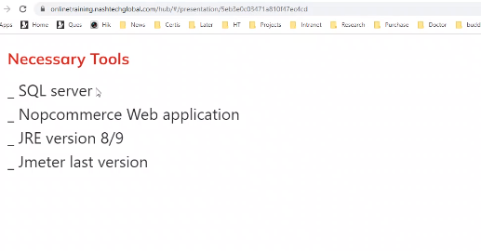

Set up web to practice: guide video https://harveynashvn-my.sharepoint.com/personal/lampham_nashtechglobal_com/_layouts/15/stream.aspx?id=%2Fpersonal%2Flampham_nashtechglobal_com%2FDocuments%2FRecordings%2F%5BCompany%20Training%5D%20Performance%20Test%20Training%20_%20Nov-20211102_100035-Meeting%20Recording.mp4&ga=1

1. SQL server 2016..(mydungxd2/Testing@123) -> SSMS

Connect use Window Authenticate to create account test on DB

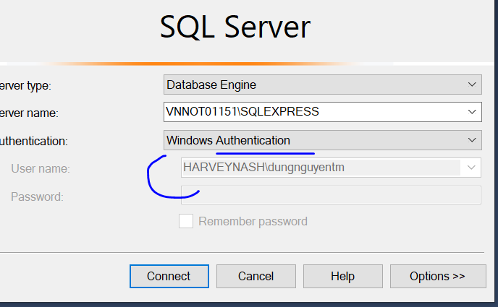

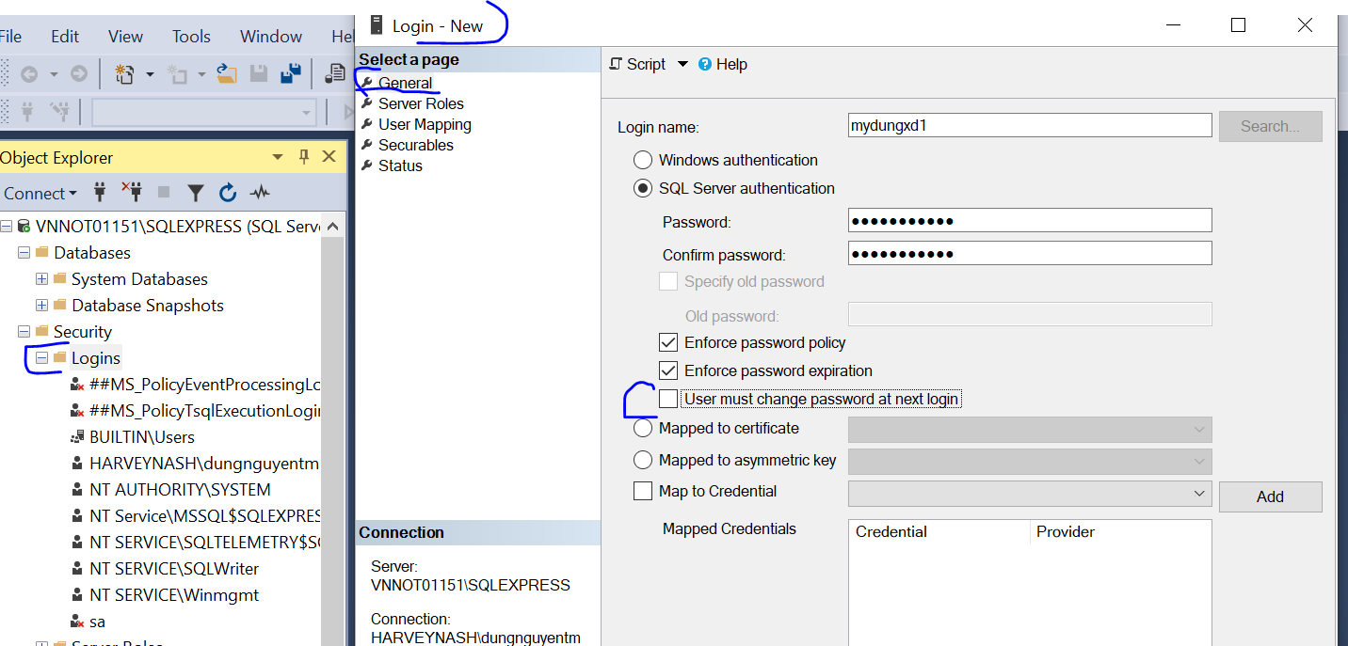

Admin permission for this account

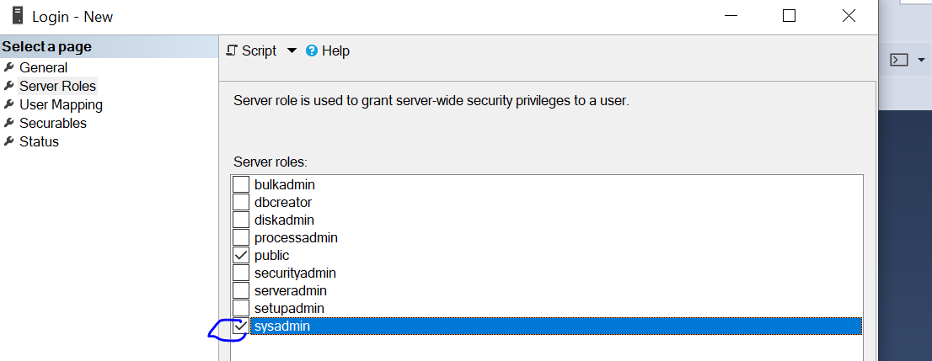

Before connect to account use User Authentication --- https://www.youtube.com/watch?v=aU8RhjdkCoE

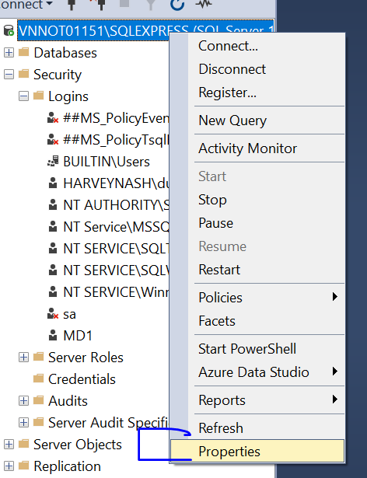

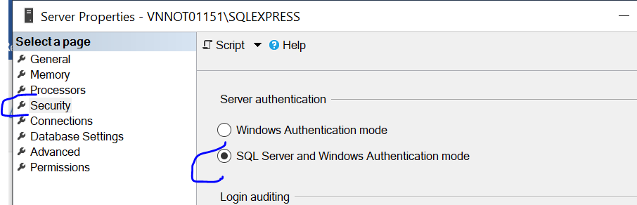

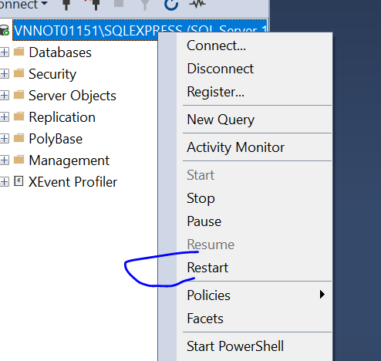

Then connect this account

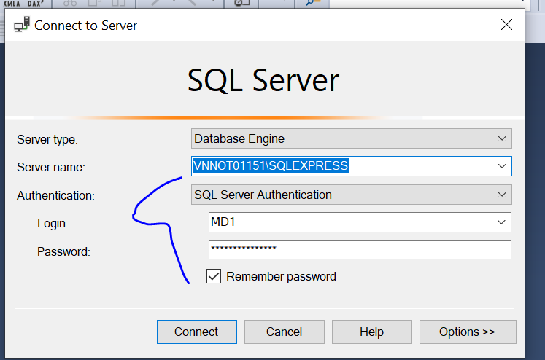

1. Down nopcommerce – no source (admin: dung@gmail.com/123456-> run nop.webs.exe -> purpose: Create 1 website to practice
2. Copy this link to FF 
3. On FF

If PC ko cho run nop.web.exe, right click lên file exe then Propertive -> click vô ô Unclock -> Apply – sau đó sẽ run dc

Install Jmeter tool:

Jun Java  before install Jmeter tool

1. Download & install JRE: https://www.java.com/en/download/
2. Run bin -> jmeter.bat to open Jmeter tool
3. 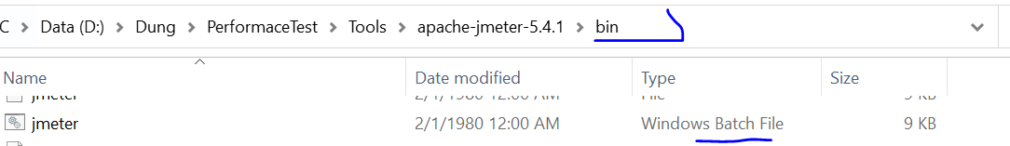
4. Run Template for Recording
5. 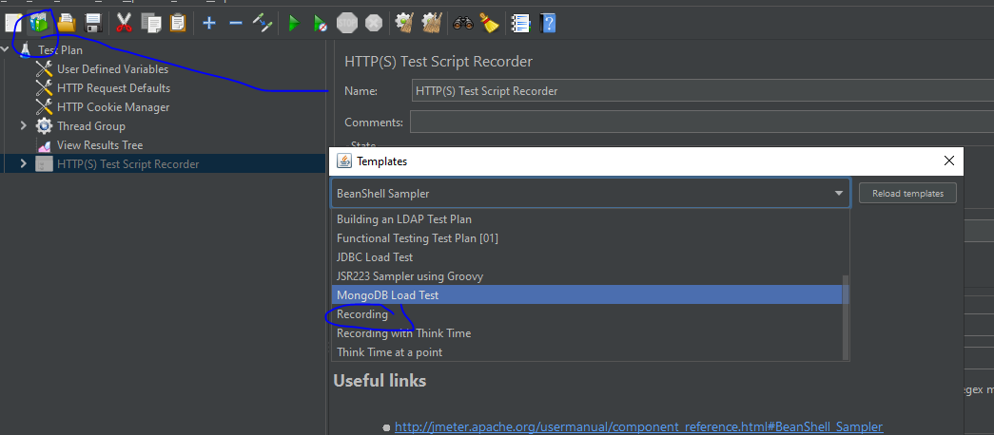

Use Firefox to record:

+ Config FF: same port…

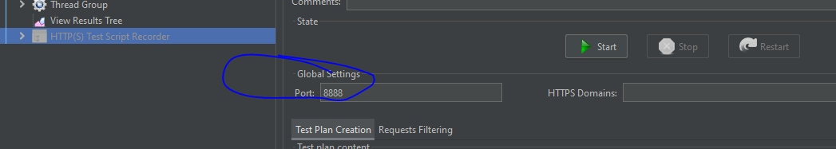

On Firefox:

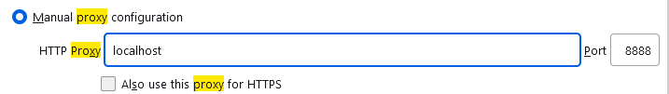

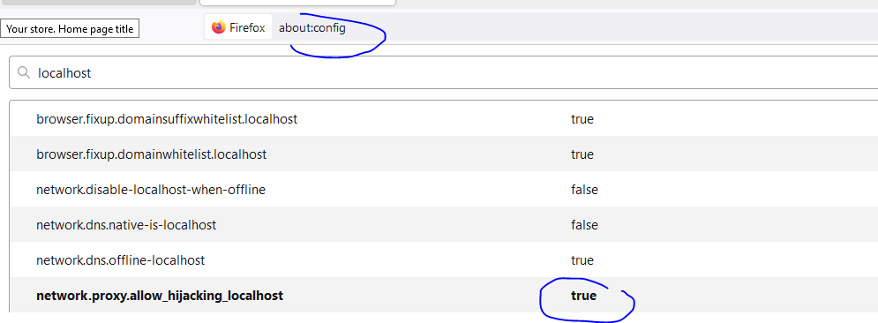

**Add certificated to FF**

**Reference document:** [Performance Testing Guidance for Web Applications | Microsoft Learn](https://learn.microsoft.com/en-us/previous-versions/msp-n-p/bb924375(v=pandp.10)?redirectedfrom=MSDN)

Using this page to extract string of token **:** [**https://regex101.com/**](https://regex101.com/)

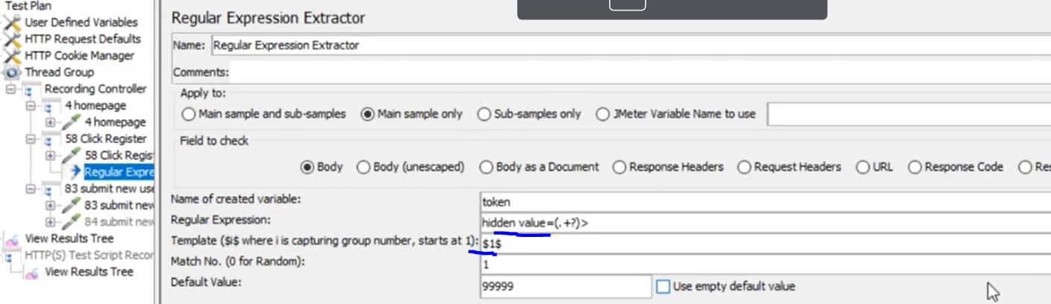

**Nop commerce:**

Admin: [mydungxd1@gmail.com/Testing@123](mailto:mydungxd1@gmail.com/Testing@123)

**S1:** Some Users views some products (random products) – Some users add products to cart – Admin check orders

C1: 5 users register new and add new address – loop 2m?

Regular Expression Extractor – Variables - Counter – Timer

C2: View random product

Random controller